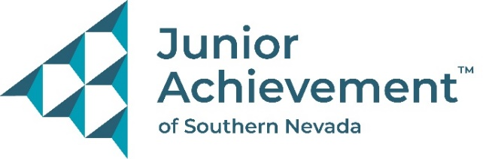

Date
FOR IMMEDIATE RELEASE:


Junior Achievement of Southern Nevada
Announces New Board Member Elizabeth Delgado
from Every Season Wealth Management
LAS VEGAS – Junior Achievement of Southern Nevada is proud to announce Elizabeth Delgado has joined its board of directors. She is a founder and private wealth advisor for Every Season Wealth Management. Her extensive experience in financial planning, strategic planning and relationship building and development will be invaluable in helping the nonprofit organization achieve its mission to empower K-12 youth to own their economic success.
“Through Elizabeth’s work in banking, investment management and financial planning and commitment to our mission-aligned values, her expertise and passion will make a significant impact as we grow our efforts to help more students learn about financial literacy, workforce development and entrepreneurship,” said Michelle Jackson, chief executive officer and president of Junior Achievement of Southern Nevada.
As a graduate of the Vegas Chamber’s Leadership Las Vegas program, she was able to learn more about Junior Achievement. She has volunteered with JA for years, in the classroom, at Finance Park, and with the 4.01K race, and fell in love with the nonprofit’s mission all over again.

She’s supported JA through various fundraisers, the annual Swimming with the Big Fish luncheon, and Finance Park, her favorite program that combines in-class learning with a hands-on budgeting simulation. She plans to increase her JA volunteerism and invite her Every Season Wealth Management team to join her.
Delgado also serves on the board for Scarlett Hope, a nonprofit organization that shares the hope and love of Jesus with women in the adult entertainment industry. She also sat on its Operations Board and held numerous volunteer positions from greeting, prayer, communion service, and lead study groups with Canyon Ridge Christian Church.
Born in Queens, New York, and raised in Southern California, Delgado studied finance at UNLV. She received the Accredited Asset Management Advisor and Accredited Wealth Management Advisor designations through the College of Financial Planning and is working on an Accredited Behavioral Financial Advisory designation.

About Junior Achievement of Southern Nevada
Junior Achievement of Southern Nevada, Inc. was founded locally in 1996. The organization is dedicated to providing financial education to students K-12, with a curriculum that spans from budget management to economic principals, workforce skills and credit. Junior Achievement of Southern Nevada reaches more than 20,000 students annually in the Las Vegas area with the help of 285 businesses and 6,800 business role models. For more information visit https://jasnv.org/ and follow on Instagram and Facebook.

About Junior Achievement USA® (JA)
Junior Achievement is the world's largest organization dedicated to giving young people the knowledge and skills they need to own their economic success, plan for their future, and make smart academic and economic choices. JA programs are delivered by corporate and community volunteers, and provide relevant, hands-on experiences that give students from kindergarten through high school knowledge and skills in financial literacy, work readiness and entrepreneurship. Today, JA reaches 4.5 million students per year in 115 markets across the United States, with an additional 5.8 million students served by operations in 120 other countries worldwide. Visit www.ja.org for more information.

# # #

